CHANDRA VUNNAM

2420030291

S-2

**Computer Networks - 24CS2202**

**Experiment: 5 –** Configuration of Encapsulation dot 1Q using cisco packet tracer

**Step 1: Set Up Your Network**

1. Open **Cisco Packet Tracer**.
2. Drag and drop:
   * Two **3560 multilayer switches**.
   * At least **4 PCs**.
3. Connect PCs to switches using **copper straight-through cables**.
   * PC0 → Switch0 (Fa0/1)
   * PC1 → Switch0 (Fa0/2)
   * PC2 → Switch1 (Fa0/1)
   * PC3 → Switch1 (Fa0/2)
4. Connect **Switch0 and Switch1** using a cable (choose Fa0/3 or Gig0/1).

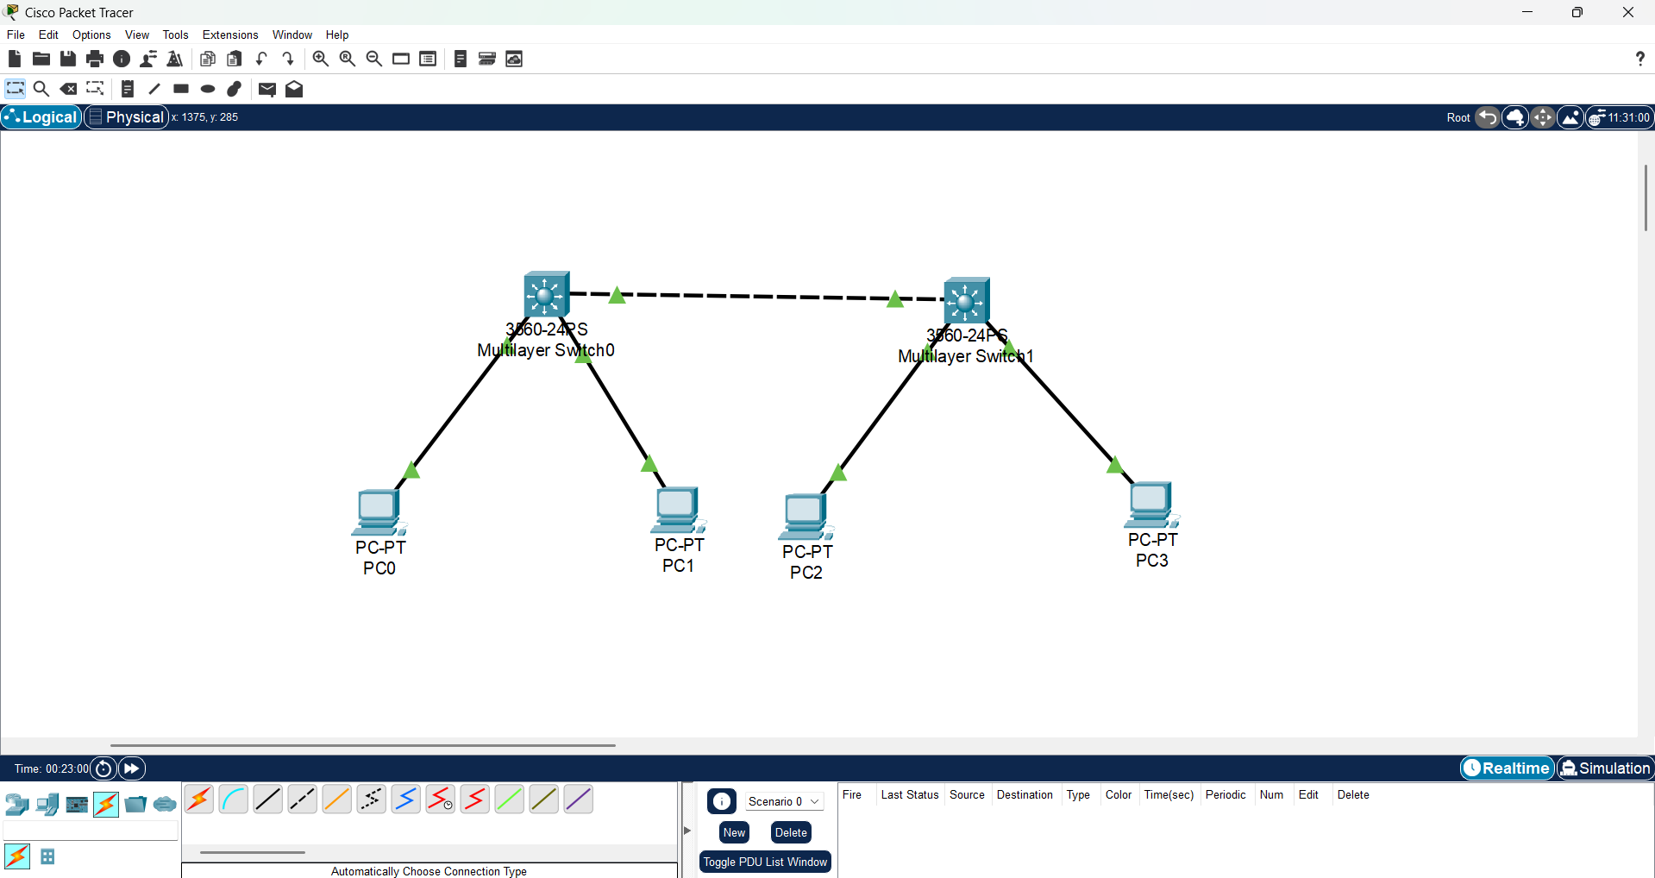

**Step 2: Configure VLANs on Switches & Configure Trunk Between Switches**

Switch 0:-

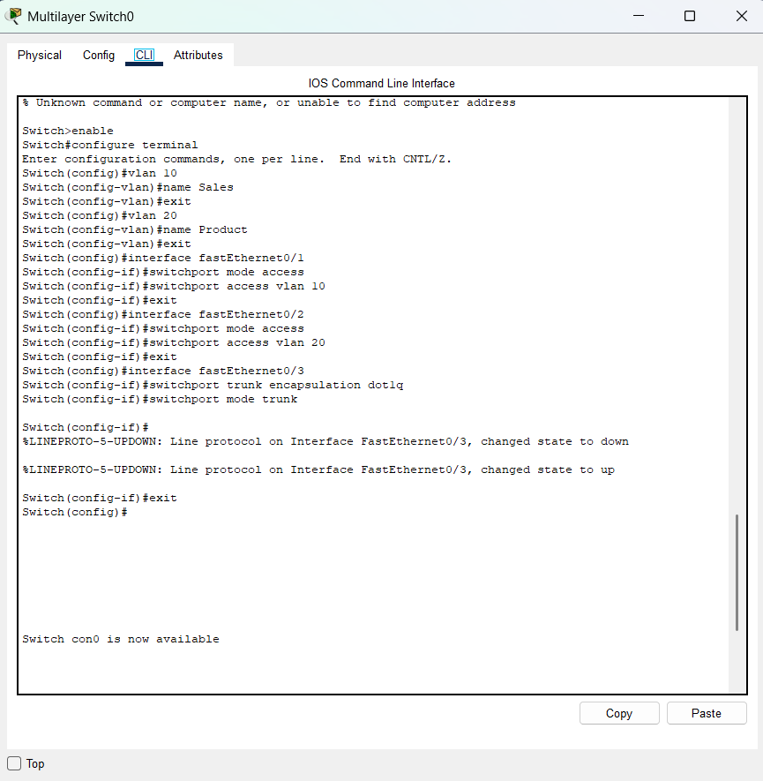

Switch 1:-

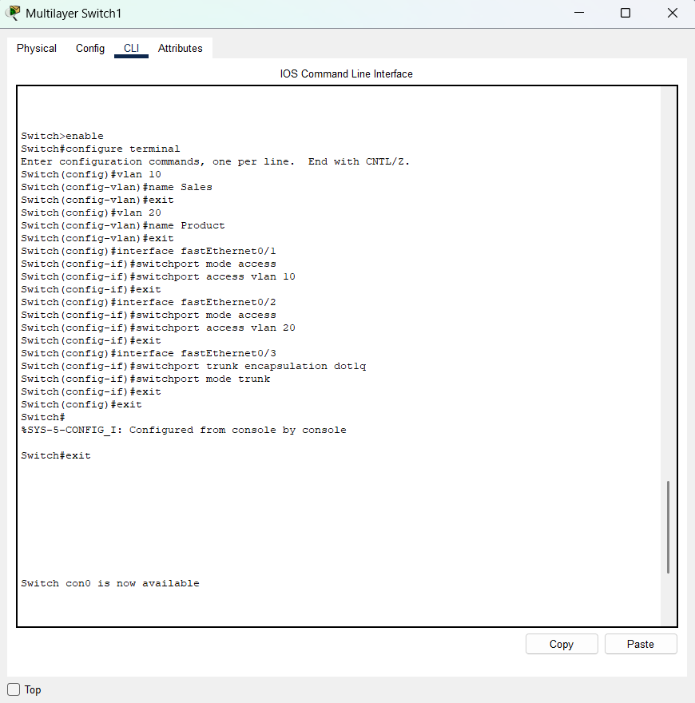

**Step 3: Assign IP Addresses to PCs**

Click **PC0** → Desktop → IP Configuration:

IP: 192.168.10.2

Subnet: 255.255.255.0

Gateway: 192.168.10.1

**PC1:**

IP: 192.168.20.2

Subnet: 255.255.255.0

Gateway: 192.168.20.1

**PC2:**

IP: 192.168.10.3

Subnet: 255.255.255.0

Gateway: 192.168.10.1

**PC3:**

IP: 192.168.20.3

Subnet: 255.255.255.0

Gateway: 192.168.20.1

**Step 4: Verify VLAN & Trunk Configuration**

**Switch 0:-**

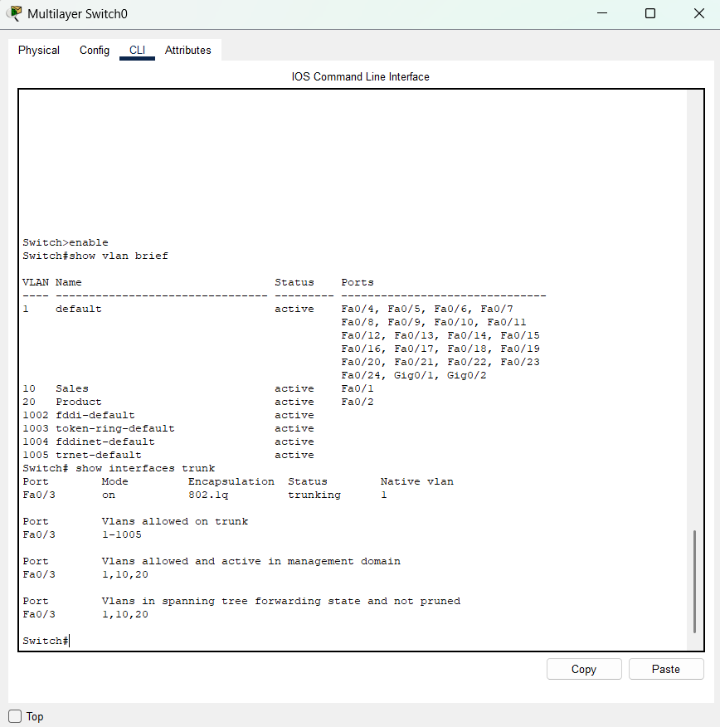

**Switch 1:-**

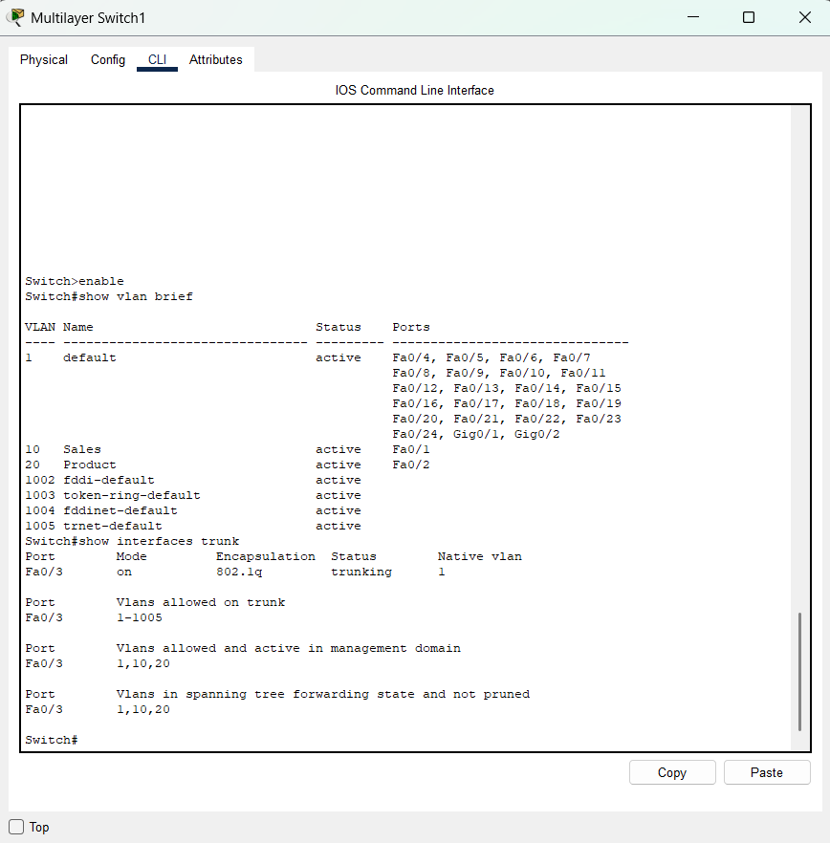

**Step 6: Test Connectivity:-**

